Introduction
In the wake of the issuing of the Emancipation Proclamation and Federal forces occupying more and more Confederate territory, it became increasingly evident that the creation of an organization to manage all the issues in occupied Confederate territory was necessary. This resulted in the creation of the Bureau of Refugees, Freedmen, and Abandoned Lands, more commonly known as the Freedmen’s Bureau, in 1863 which sought to aid the refugees, abandoned lands and property, and newly freed slaves in the newly occupied territory. With the capitulation of the Confederacy in 1865 and the beginning of the Reconstruction of the Southern States, the Bureau’s operations expanded drastically as they were now responsible for helping the poor and destitute people in the war-torn South while also helping newly freed slaves gain a foothold in a society which was actively hostile to their existence.
Problem Statement
The purpose of this paper is to list the goals and activities of the Freedmen’s Bureau in Mississippi, and to gauge the extent to which the Freedmen's Bureau was able to successfully complete and carry out their objectives. The Freedmen's Bureau has often been associated with the complete failure of Reconstruction, and this paper will seek to determine whether the Freedmen's Bureau made a permanent impact on freed people or if it was just another failed program of Reconstruction.
Research Questions
1: To determine what objectives and goals the Freedmen’s Bureau set in Mississippi regarding freed people, and the Bureau’s ability to aid freed people in their new position in society.
2: To determine the actions that the Freedmen’s Bureau took to aid and support freed people in Mississippi in alignment with the organizations stated goals and objectives.
3: To determine if the Freedman’s Bureau was able to achieve its goals regarding freed people through its actions in Mississippi.
Definitions
Freedmen’s Bureau: An offshoot branch of the Federal Army that existed from 1863 to 1872 that sought to aid poor southern civilians, help newly freed slaves establish themselves in society, and to manage confiscated and abandoned lands.
Free People, Freedmen, etc.: African American Ex-slaves which were freed from slavery following the passing of the Emancipation Proclamation in 1863 and the end of the Civil War in 1865.
Military Protection: A scenario in which a conflict between white civilians or officials and freed people requires the intervention of an armed detachment of Federal troops to the area in order to resolve the situation.
Material Aid: Aid given in the form of food rations, medical aid and facilities, and shelter to freed people by the Freedmen’s Bureau.
Legal Aid: Aid in the form of legal representation of freed people in court, mediating labor contracts between black workers and white employers, rebutting state and local laws discriminating against free people, and resolving disputes regarding freed people by the Freemen’s Bureau.
Educational Aid: Aid in the form of funding the construction and purchase of colored schools, providing staff for colored schools, and funding the operation of colored schools by the Freedmen’s Bureau for the education of freed people.
Limitations of Study
Some limitations of the study is that the primary sources that I am limited to are letters from the Civil War and Reconstruction Governors of Mississippi, which are a collection of letters from 1860 to 1877 that were sent to the governors of Mississippi. This is an issue because the letters are missing the prospectives of the freed people because at the time freed people weren’t likely to be literate and even less likely to write to the governor, and that’s assuming that if a freed person wrote to the governor that their office would keep the letter. Another limitation is that Reconstruction was a failure in its entirety, which serves to diminish the accomplishments that the Freedmen’s Bureau and Reconstruction was able to achieve within the popular notions of American history.
Assumptions
Reconstruction is often seen as one of the great sore spots of American history because it was poorly handled and funded from the start, and Reconstruction failed to achieve most of its long-term goals. As a part of Reconstruction, the Freedmen’s Bureau is also seen as a failure, and for this study I must not think of the Freedmen’s Bureau as a failure to fairly write about the actions of the Bureau in Mississippi.
Importance of Study
This study is important to provide a fair assessment of the actions of the Freedman’s Bureau in Mississippi because despite the Bureau being active in one of the most critical moments in black history, it is often tied in with the failures of Reconstruction. Despite its flaws the Freedmen’s Bureau provided freed slaves with aid and opportunities to better themselves in a society which actively saw their existence as a threat to the South as a whole. This study will also make use of GIS and data visualization in order the geographic reach of the Freedmen’s Bureau and its aid, as well as describing what areas received aid and what kind of aid to more deeply understand the Bureau’s activities in Mississippi.
Literature Review
Richard Fleischman, Thomas Tyson, and David Oldroyd, “THE U.S. FREEDMEN’S BUREAU IN POST-CIVIL WAR RECONSTRUCTION.,” Accounting Historians Journal 41, no. 2 (December 1, 2014): 75–109.
In this article, Fleischman, Tyson, and David seek to gauge how effective the Freedmen’s Bureau was at achieving its stated goals in Mississippi, and whether the actions of the Freedmen’s Bureau can be lumped with the wholesale failure that was reconstructed (75). Fleischman, Tyson, and David determined the successfulness of the Freedmen’s Bureau by analyzing the organization massive paper trial to find whether the Bureau was able to provide labor contracts that wear fair to both white employers and black laborers, providing a functional education system for the freed slaves, providing aid to destitute freed people, and providing legal protection and representation for freed people in court (91-92, 99-100). In conclusion while the paper determined that the Freedmen’s Bureau did provide vital aid and services to freed slaves, that it was held back form lack of funding from Washington because of the fear that freed people would become solely reliant of federal aid, the fear that the Freemen’s Bureau as an overextension into the rights and responsibilities of the States, the rapid demobilization of the Army that the Bureau was apart of, and the massive amount of local resistance that the Bureau faced from local whites in the South (103-106).

Ira C. Colby, “The Freedmen’s Bureau: From Social Welfare to Segregation,” Phylon (1960-) 46, no. 3 (1985): 219–230.
Colby states that Freedmen’s Bureau was one of the first national level welfare programs initiated in the United States but was tempered from a lack of organization direction which ended up imposing the national accepted notion of racial segregation upon the newly freed slaves of the South. The Freedmen’s Bureau’s inconstancy can be traced back to its roots it congress where moderate and radical Republicans arguing on just how far reaching the goals of the Bureau should be, which ended up with the Freedmen’s Bureau having a vague set purpose of “aiding the freedmen” (220-221). Although the Freedmen’s Bureau was able to provide plenty of social welfare program to freed people, the bureau was thoroughly neutered when it came under the direct control of the standing army with the Military Reconstruction in 1867 and the readmission of Southern states back into the Union in the following years, which served to limit the ability of the Bureau to preform its duties by both the military authorities and the newly re-instated Southern state governments (224-225). But the greatest failure of the Freedmen’s Bureau was that it followed the notion of segregation that was accepted in both the North and the South that created to separate social systems for the black and white populations in the South whose effects can still be felt today (228-229).

Robert C. Lieberman, “The Freedmen’s Bureau and the Politics of Institutional Structure,” Social Science History 18, no. 3 (1994): 405–437.
In this article Lieberman seeks to look at the effectiveness of the Freedmen’s Bureau from a standpoint of overall bureaucratic efficiency in terms of how well the Bureau has able to fulfill its role without taking into consideration the failure of the long-term goals of the organization (406). Despite the hostile environment that the Freedmen’s Bureau emerged in 1865, with President Johnston and a more moderate congress limited the reach of the Bureau, the organization was able to effectively fill its more limited role as a welfare agency because being an offshoot of the army, the workers of the Bureau were more than capable of running a large aid providing network across the South (413-414, 417). But as Congressional Reconstruction began to take place, the Bureau was transformed from purely a welfare organization to a body that was supposed to protect and support the legal rights of the free people which the organization was ill-prepared to carry out both in terms of manpower and organizational structure (425-428). In combination with the Bureau’s expanded goals, more and more civilians were joined the Freedmen’s Bureau, which only politicized the organization and hampered its ability to take on its newly expanded roles (427-429). In short, when the Bureau was limited in scope and was run solely by the military it was able successfully achieve its goal of giving aid to freed people, but the organization collapsed in on itself as it couldn’t handle the politicalization and expanded size and scope brought onto the organization by Congressional Reconstruction (431-433).

Marjorie H. Parker, “Some Educational Activities of the Freedmen’s Bureau,” The Journal of Negro Education 23, no. 1 (1954): 9–21.
In this article Parker looks at how the Freedmen’s Bureau helped promote education among the newly freed slaves in the South and what impact this aid had (9). The Freedmen’s Bureau did not establish or run schools outright, but instead the organization purchased land or buildings to be turned into schools, provided aid to established schools and educational organizations, and provided oversight to the multiple freed people’s schools throughout the South (10-11). Most of the teachers and staff for these newly established schools came from various benevolent and religious societies from the North which sought to aid the newly freed slaves as humanitarian aid, because it was seen as necessary for freed people to acquire a higher education in order to fully distance themselves from slavery and to function in society (18-20). In conclusion, the Freedmen’s Bureau provided the monetary and logistical backbone for the education of freed people, while charitable and religious organizations from the North provided the manpower necessary to keep these schools operational (20-21).

Downs, Gregory P. After Appomattox: Military Occupation and the Ends of War. Cambridge: Harvard University Press, 2015.
In his book, Downs states that the army was critical in providing peace and aid to the newly freed slaves in the South which was actively hostile to them (10). The army provided both aid and protection to the freed peoples due to their sheer proximity and numbers in the South, with Downs stating that, “The army, despite its many limitations, was their most proximate, powerful ally in the battle to assert their rights of freedom. Ex-slaves did not move to the blank space of freedom but to the government that seemed to have power to defend their rights” (10). However, as reconstruction progressed it faced a series of setbacks in the form of demobilization which limited the army’s effective range and active hostility from Johnston who was pushing for the return of civil governance which extremely hampered the army’s ability to accomplish its goals (89-91, 116-117). In short, the Army proved to be an invaluable source of protection and aid for the freed people in the South, but as the Army rapidly demobilized after the end of hostilities this source of aid a protection for freed people disappeared as well (116-117).
Methodology
For my primary sources, I pulled them primarily from the Civil War and Reconstruction Governors of Mississippi (CWRGM) project, which entails letters that were sent to the Governors of Mississippi from 1860 to 1877 that were archived by the Governor’s office and later digitized and transcribed. To find the letters that I used I used the tag “Bureau of Refugees, Abandoned Lands, and Freedmen”, which is the full name of the Freedmen’s Bureau, and I also used the same tag in an Excel sheet that contained a consolidated list of the CWRGM subject tags. The other primary source I used was a list of the active Army Units and Freedmen’s Bureau agents in Mississippi from the Army’s archival databases. For my secondary sources, I pulled scholarly journal articles from the University of Southern Mississippi’s library database and from JSTOR with the tags “Bureau of Refugees, Abandoned Lands, and Freedmen”, “Freedmen’s Bureau”, “Reconstruction”, and “US Army”.
The reason why I picked my sources the way that I did was that I was searching for sources that were pertaining to how the Freedmen’s Bureau interacted and aided freed people in Mississippi in particular. Because of that, I had to omit sources that talked about the Bureau’s other duties, such as managing abandoned lands and helping white refugees, and that were focused on other geographic areas in the South because they did not aid me in evaluating the Freedmen’s Bureau’s effective in Mississippi. I will use my primary sources of the CWRGM letters and the Army and Bureau statistics to help me with my argumentation within my paper and research poster, as well as providing the data that will be used to make a GIS map of the Bureau’s actions in Mississippi. As for the Secondary sources, they will be used primarily to support my argumentation in my paper and poster and will be used to determine the Freedmen’s Bureau’s overall effectiveness in Mississippi because primary sources and census data can’t provide a retrospective look at if a current organization is successful or not.
For my GIS map I pulled the location data for my letters from the CWRGM website and the subject tags that were provided for me by the Mapping Freedom project staff. For the locations of the Freedmen’s Bureau offices, I pulled the names of the cities that the offices were in through the Freedmen's Bureau Transcription Project, and then I pulled the latitude and longitude of the offices from Google. For the location and number of Federal troops I pull the data from the Mapping Occupation project by Gregory P. Downs, whose book, After Appomattox, I used in the project as well. The reason why I used the CWRGM letters, Freedmen’s Bureau offices, Federal troop location and numbers in Mississippi, and the location of major railroads in Mississippi is because I want to see if there is a correlation between the location of letters requesting aid from the Bureau and the location of Freedmen’s Bureau offices, Federal troops, and railroads in Mississippi. All citations for the sources used on the map will be listed in the appendix of the paper.

Results
After sorting and organizing through the letters, these are the following graphics that have been created in order to visualize data that display the types and location of aid that the Freedmen’s Bureau provided to freed people in Mississippi. Table 1 represents the comparison of the different types of aid provided by the Freedmen's Bureau which was food and medical aid (material aid), legal aid, military protection, and educational aid. Figure 1 through 5 shows the geographic spread of the aforementioned types of aid with the letters in QGIS in comparison to the location of Federal troops, Freedmen’s Bureau offices, and railroads in Mississippi. Table 2 shows the total amount of Federal troops deployed in per year Mississippi throughout the course of reconstruction.
For the results of my research, I found that on the map the locations of the CRWGM letters asking for aid from the Freedmen’s Bureau or showing the Freedmen's Bureau providing aid to freed people, are all located near either the location of Bureau offices and railroads or areas where Federal troops are stations. In contrast to this, in areas where now Bureau offices or Federal troops are not present, such as central Mississippi, there is almost a complete absence of letters asking the Bureau for aid or the Bureau giving aid in these areas. However, in areas in which the there are Bureau offices and Federal troops, the letters indicate that the Freedmen’s Bureau did provides services ranging from providing aid in the form of food and medicine, armed protection, legal representation and advocacy, resolving disputes between black laborers and white employees, and providing medical and educational facilities for the freed people of Mississippi.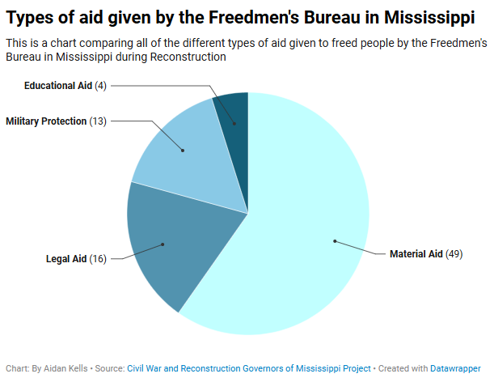
Despite a main tenet of the Freedmen’s Bureau being to promote the education of Freedmen, there are a surprisingly small number of letters mentioning the Bureau being directly involved with the education of freed people, with only 4 of the 91 letters pulled from CWRGM about the Bureau being about education. However, this can be explained by the fact the Bureau rarely actually staffed colored schools with teachers and other staff because multiple northern benevolent societies did the boots on the ground jobs as educators and school staff, but instead provided aid to these institutions through purchasing property for schools and funding their construction and operation. This can be seen in the letters, as the two letters about the Bureau and the education off freed peoples is about the Bureau acquiring a new building for a colored school. This lend credence to the reason behind their being fewer letters about the Bureau’s involvement in education of freed people is because they mainly outsourced the actual educational roles to benevolent and religious societies while the Bureau took a more administrative role, thus resulting in less letters being sent to the Governor of Mississippi about the education of freed peoples.
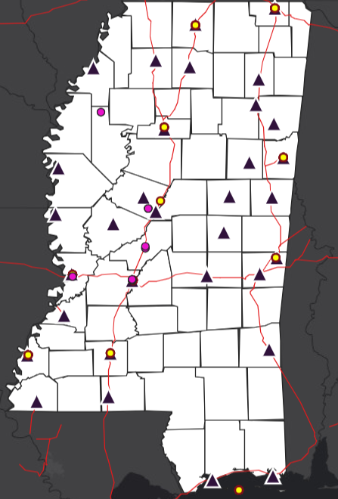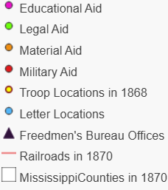
The second largest category of letters are about the Freedmen’s Bureau providing physical protection to freed people and providing them with legal protection and advocacy at both the state and local levels. This shows just how actively opposed white Mississippians were to former slaves integrating into southern society and highlights how important the Freedmen’s Bureau and the Army was in protecting freed people exist in a society that was actively violent towards them. The letters also reveal just how the Bureau fought for the legal rights of freed people, with the Bureau resenting freed people in court and labor contracts and constantly demanding the repeal of state and local laws that are discriminatory against freed people. Despite the main objectives the Freedmen’s Bureau being the advancement of freed people out of slavery and into southern society, the letters show that the Bureau also had to protect freed people both physically and legally for a society that was hostile to their very existence.
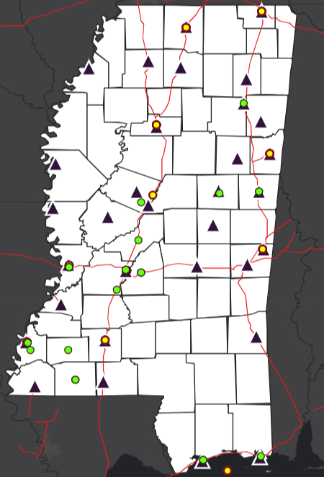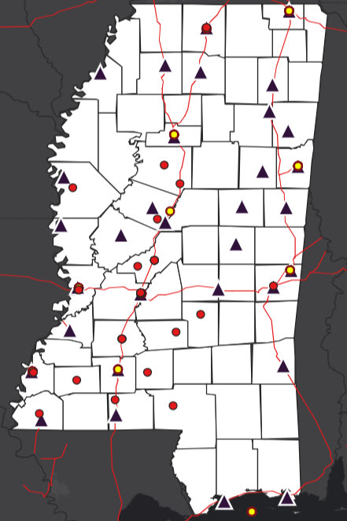
The largest proportions of the letters pertains to the Freedmen’s Bureau providing aid to both destitute black and white people, though for the purposes of this paper only letters about black families receiving aid will be reviewed. The type of aid that the Bureau provided to freed people ranged from food rations and medical supplies to providing shelter to homeless freed people and providing medical staff to hospitals for colored people. However, aid was not distributed evenly, as letters regarding the distribution of food and medical aid are centralized around Jackson, while letters about providing housing for freed people are located throughout the more rural parts of Mississippi. Although material aid was not distributed evenly across Mississippi, it was by far the largest kind of aid distributed across both Mississippi and the South because of the Bureau being a part of and staffed by the Army in which distributing resources across a wide geographic area in a set amount of time was a skill that they had perfected during their time in the military.
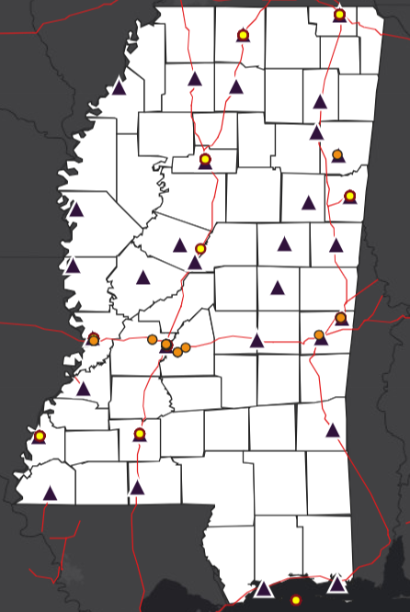

Discussion
Considering the findings of charts, it is clear to see that the Freedmen’s Bureau was in fact a success with its operations in Mississippi. This is because as a social welfare agency it was able to provide military protection, educational aid and opportunities, legal protection and representation, and material goods and services to freed people across a majority of Mississippi. This is because the military structure and personnel of the Freedmen’s Bureau allowed for it to distribute large amounts of aid across a large geographic area due to the fact that military personnel had plenty of pre-existing experience managing complex supply lines during the war. Another factor was contributing to the Bureau’s success was the large amount of Federal troops present in Mississippi which served as the Bureau’s “boots on the ground” because they were the ones intervene on the Bureau’s behalf in situations as well as enforcing the Bureau’s ordnances in Mississippi.
However, despite the data showing that the Bureau was an effective welfare agency, it would be unwise to completely ignore the Bureau’s many failings which undermined its ability to achieve their stated objectives. First off, though the Bureau’s aid reached a large part of Mississippi, it was centered around areas which had Bureau offices and army stations, and areas that lacked such features, like central and southern Mississippi, received far less aid as a result. Also the Bureau in following with Elizabethan era poor laws, was often concerned about giving too much Federal aid to freed people, as it was afraid of “pauperizing” them so that they were solely reliant on the government for their existence. This resulting in hesitation on the Bureau’s part when deciding to send aid to areas that desperately needed Federal assistance to survive in the short term. Perhaps the greatest flaw of the Bureau was that it help form the notion of racial segregation in the South by providing sperate aid services to black and white civilians instead of providing integrated services, the Bureau only served to reinforce the notion of segregation amongst races. Despite the Bureau’s many flaws, it was still able to create a successful welfare system for freed people across Mississippi which provided them with critical services to help them adjust to the post slavery world.
Though one big question remains in the study, “if the Freedmen’s Bureau was so effective in its role in Mississippi, then why was the organization shut down in 1871?”. The answer to the question lays in a series of internal and external events that slowly diminished the Bureau’s effectiveness until it was a shell of the organization that it once was. The most pression issues facing the Bureau was the rapid demobilization of the Federal Army in the late 1860’s, as the quickly reducing troop numbers in Mississippi effectively wiped out the organization’s “boots on the ground” and its ability to enforces its decisions. The reduced troop numbers in Mississippi allowed for local governments to pass more and more discriminatory laws against freed people without fear of reprisal, which served to undo much of the Bureau’s work with freed people.Another hinderance to the Bureau’s operations came from the Federal government itself, as when Congressional Reconstruction began in earnest the Bureau’s mission was changed from providing social welfare to freed people to protecting their civil rights which the Bureau was ill equipped to handle because of the difficulty of enforcing such an order and because of Bureau hemorrhaging manpower. Another change in the Bureau brought about by Congressional Reconstruction that hurt organization was the shift to a primarily civilian make-up of the Bureau as compared to the military, which brought a litany of issues to the Bureau such as politization, civilians putting self-interest over the organization’s wellbeing, and general slowness and inefficiency. In short, while the Freedmen’s Bureau proved to be highly effective as a welfare agency early on, external and internal changes ground the Bureau’s progress to a halt so by 1871 it was an ineffective husk of its former self just 4 years ago.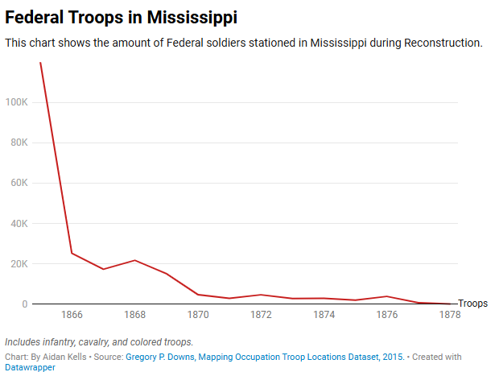

Conclusion
In conclusion, the Freedmen’s Bureau was able to achieve its goals of aiding freed people adjust from a society where they were slaves, to a post-plantation society where they were now free citizens. The Bureau was able to accomplish this by distributing various types of material and non-material aid relatively equally across most of Mississippi to freed people in need and to help them improve their standing in society through education and legal representation. However, despite the Bureau’s early effectiveness, the program was shut down in 1871 because of changes to the organization’s policies and mission, the Bureau transforming into a mostly civilian run operation, and massive resistance from white Southerners and the rapid mobilization of the Federal Army crippled the Bureau so that it could no longer operate effectively as a social welfare organization.

Works Cited
Civil War and Reconstructions Governors of Mississippi Project. https://cwrgm.org/
Downs, Gregory P. After Appomattox: Military Occupation and the Ends of War. Cambridge: Harvard University Press, 2015.
Gregory P. Downs, Mapping Occupation Troop Locations Dataset, 2015.
Thomas, Col Samuel, Gen Thomas J Wood, Gen Alvan C Gillem, and Gen Adelbert Ames. “MISSISSIPPI HEADQUARTERS Assistant Commissioner” (n.d.).
Parker, Marjorie H. “Some Educational Activities of the Freedmen’s Bureau.” The Journal of Negro Education 23, no. 1 (1954): 9–21.
Lieberman, Robert C. “The Freedmen’s Bureau and the Politics of Institutional Structure.” Social Science History 18, no. 3 (1994): 405–437.
Colby, Ira C. “The Freedmen’s Bureau: From Social Welfare to Segregation.” Phylon (1960-) 46, no. 3 (1985): 219–230.
Fleischman, Richard, Thomas Tyson, and David Oldroyd. “THE U.S. FREEDMEN’S BUREAU IN POST-CIVIL WAR RECONSTRUCTION.” Accounting Historians Journal 41, no. 2 (December 1, 2014): 75–109.
Railroads and the Making of Modern America. https://railroads.unl.edu/resources/

Richard Fleischman, Thomas Tyson, and David Oldroyd, “THE U.S. FREEDMEN’S BUREAU IN POST-CIVIL WAR RECONSTRUCTION.,” Accounting Historians Journal 41, no. 2 (December 1, 2014), 79.
Richard Fleischman, Thomas Tyson, and David Oldroyd, “THE U.S. FREEDMEN’S BUREAU IN POST-CIVIL WAR RECONSTRUCTION.,” Accounting Historians Journal 41, no. 2 (December 1, 2014), 79.
Marjorie H. Parker, “Some Educational Activities of the Freedmen’s Bureau,” The Journal of Negro Education 23, no. 1 (1954): 14-16.
“Letter from H. Gardner to Mississippi Governor Benjamin G. Humphreys; May 16, 1866 · Civil War and Reconstruction Governors of Mississippi · Civil War and Reconstruction Governors of Mississippi,” mdah_779-963-04-23.
Gregory P. Downs, After Appomattox: Military Occupation and the Ends of War. (Cambridge: Harvard University Press, 2015) 42-44.
Richard Fleischman, Thomas Tyson, and David Oldroyd, “THE U.S. FREEDMEN’S BUREAU IN POST-CIVIL WAR RECONSTRUCTION.,” Accounting Historians Journal 41, no. 2 (December 1, 2014): 86-87 and 92.
Robert C. Lieberman, “The Freedmen’s Bureau and the Politics of Institutional Structure,” Social Science History 18, no. 3 (1994): 416–419.
Robert C. Lieberman, “The Freedmen’s Bureau and the Politics of Institutional Structure,” Social Science History 18, no. 3 (1994): 414–415.
Gregory P. Downs, Mapping Occupation Troop Locations Dataset, 2015 and Gregory P. Downs, After Appomattox: Military Occupation and the Ends of War. (Cambridge: Harvard University Press, 2015) 181-183.
Richard Fleischman, Thomas Tyson, and David Oldroyd, “THE U.S. FREEDMEN’S BUREAU IN POST-CIVIL WAR RECONSTRUCTION.,” Accounting Historians Journal 41, no. 2 (December 1, 2014): 104-105.
Ira C. Colby, “The Freedmen’s Bureau: From Social Welfare to Segregation,” Phylon (1960-) 46, no. 3 (1985): 228-230.
Gregory P. Downs, Mapping Occupation Troop Locations Dataset.
Gregory P. Downs, After Appomattox: Military Occupation and the Ends of War. (Cambridge: Harvard University Press, 2015) 237.
Robert C. Lieberman, “The Freedmen’s Bureau and the Politics of Institutional Structure,” Social Science History 18, no. 3 (1994): 417.
Robert C. Lieberman, “The Freedmen’s Bureau and the Politics of Institutional Structure,” Social Science History 18, no. 3 (1994): 427-430.

